**What is GIT:**

Git is a [free and open source](https://git-scm.com/about/free-and-open-source) distributed version control system

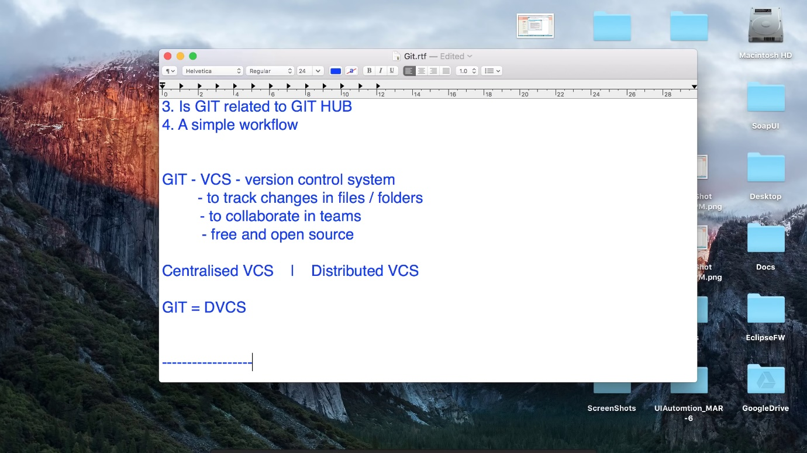

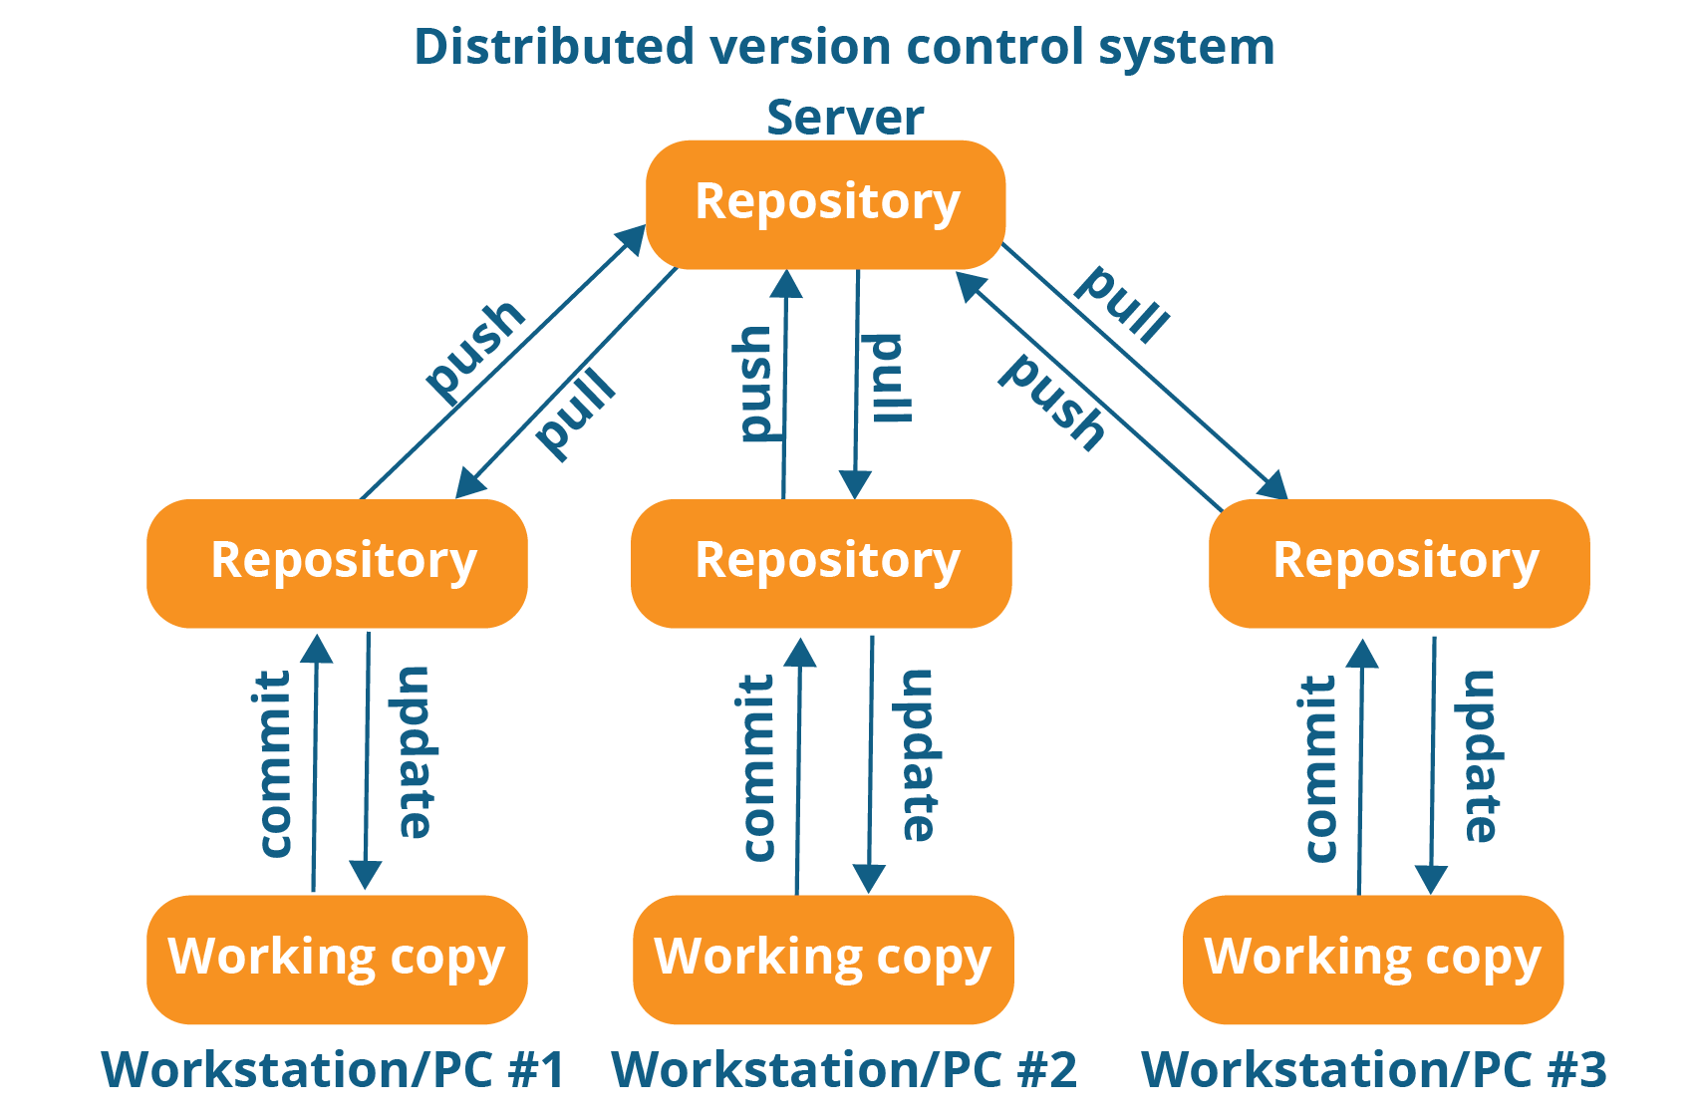

**What is GITHUB:**

GitHub is a web-based hosting service for version control using Git. It is mostly used for computer code. It offers all of the distributed version control and source code management functionality of Git as well

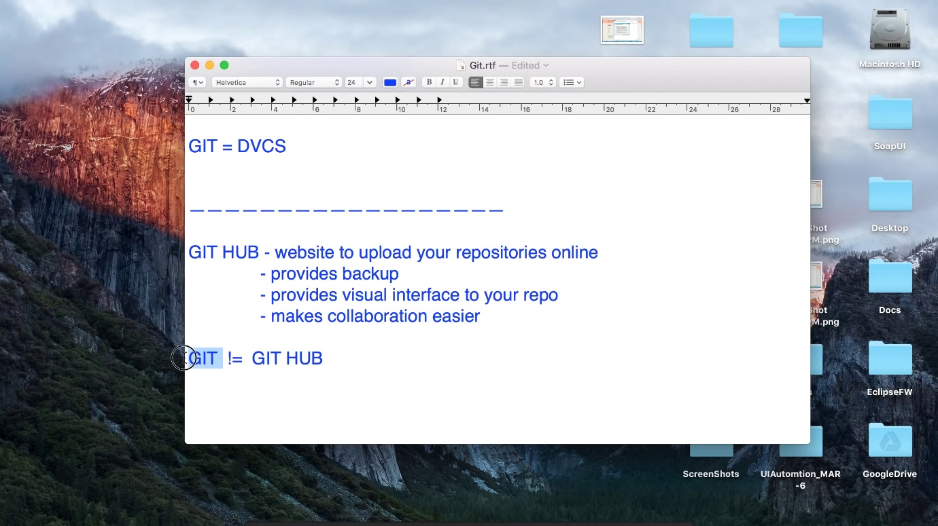

**How to install git and add project & push to remote repository(github):**

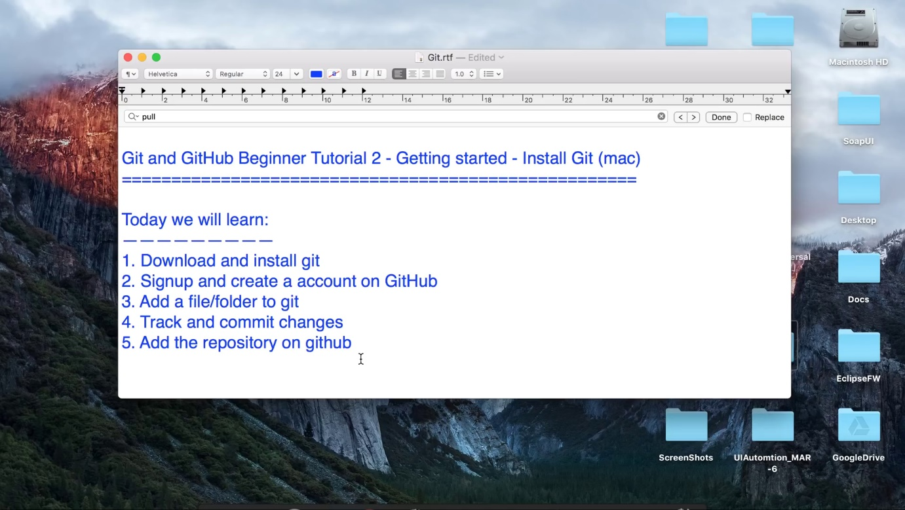

lpeddint@N-20HEPF0ZN03B MINGW64 /c/Content/web_project

$ git init

Initialized empty Git repository in C:/Content/web_project/.git/

lpeddint@N-20HEPF0ZN03B MINGW64 /c/Content/web_project (master)

$ git status

On branch master

No commits yet

nothing to commit (create/copy files and use "git add" to track)

lpeddint@N-20HEPF0ZN03B MINGW64 /c/Content/web_project (master)

$ touch test.txt

lpeddint@N-20HEPF0ZN03B MINGW64 /c/Content/web_project (master)

$ ls

test.txt

lpeddint@N-20HEPF0ZN03B MINGW64 /c/Content/web_project (master)

$ git status

On branch master

No commits yet

Untracked files:

(use "git add <file>..." to include in what will be committed)

test.txt

nothing added to commit but untracked files present (use "git add" to track)

lpeddint@N-20HEPF0ZN03B MINGW64 /c/Content/web_project (master)

$ git add test.txt

lpeddint@N-20HEPF0ZN03B MINGW64 /c/Content/web_project (master)

$ git status

On branch master

No commits yet

Changes to be committed:

(use "git rm --cached <file>..." to unstage)

new file: test.txt

lpeddint@N-20HEPF0ZN03B MINGW64 /c/Content/web_project (master)

$ git commit -a -m "create new file test.txt"

[master (root-commit) 6259dfb] create new file test.txt

1 file changed, 0 insertions(+), 0 deletions(-)

create mode 100644 test.txt

lpeddint@N-20HEPF0ZN03B MINGW64 /c/Content/web_project (master)

$ git status

On branch master

nothing to commit, working tree clean

lpeddint@N-20HEPF0ZN03B MINGW64 /c/Content/web_project (master)

$ git remote add origin https://github.com/lpeddinti/web-project.git

lpeddint@N-20HEPF0ZN03B MINGW64 /c/Content/web_project (master)

$ git push origin master

Counting objects: 3, done.

Writing objects: 100% (3/3), 223 bytes | 111.00 KiB/s, done.

Total 3 (delta 0), reused 0 (delta 0)

To https://github.com/lpeddinti/web-project.git

* [new branch] master -> master

lpeddint@N-20HEPF0ZN03B MINGW64 /c/Content/web_project (master)

$ git status

On branch master

nothing to commit, working tree clean

lpeddint@N-20HEPF0ZN03B MINGW64 /c/Content/web_project (master)

$ git pull origin master

From https://github.com/lpeddinti/web-project

* branch master -> FETCH_HEAD

Already up to date.

lpeddint@N-20HEPF0ZN03B MINGW64 /c/Content/web_project (master)

$

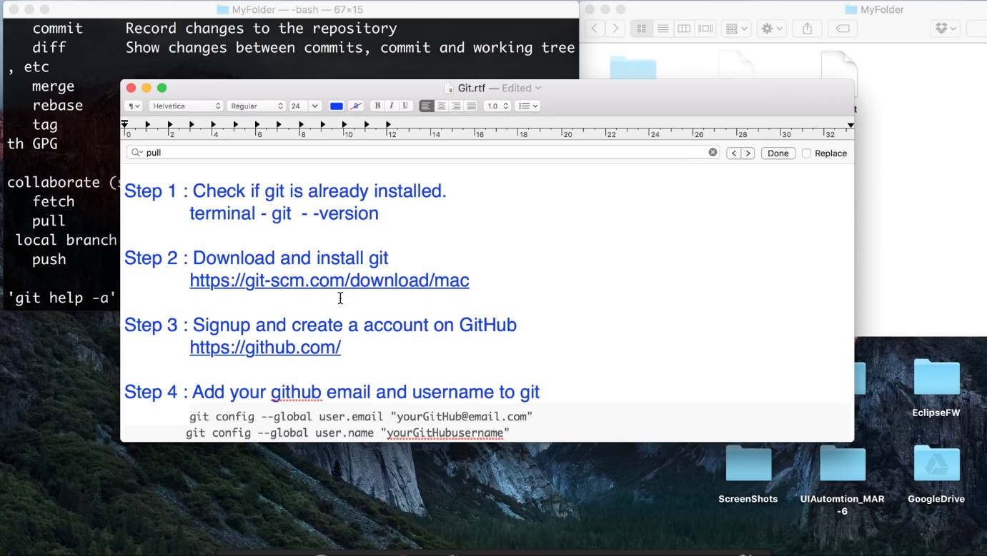

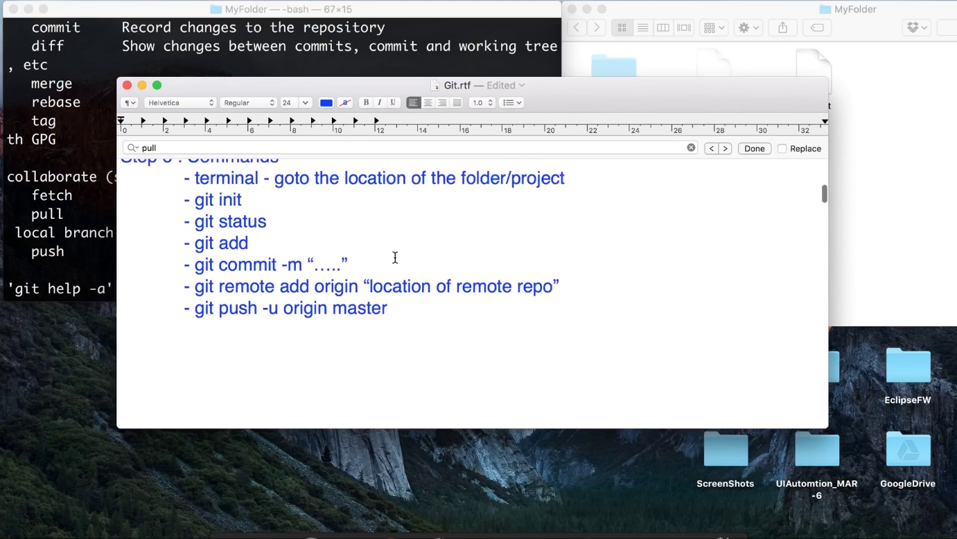

**Creating branch, merging and delete branch:**

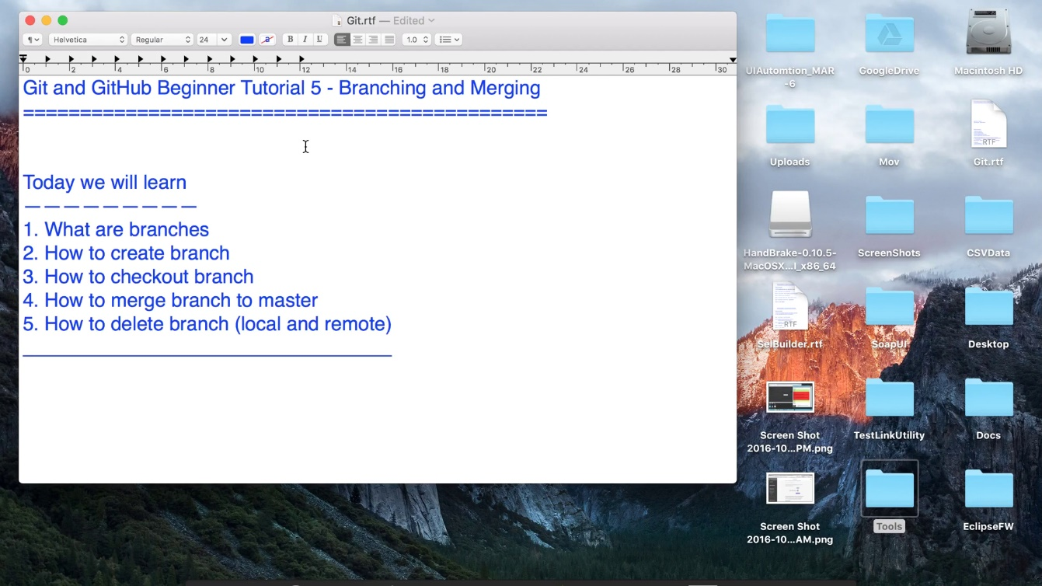

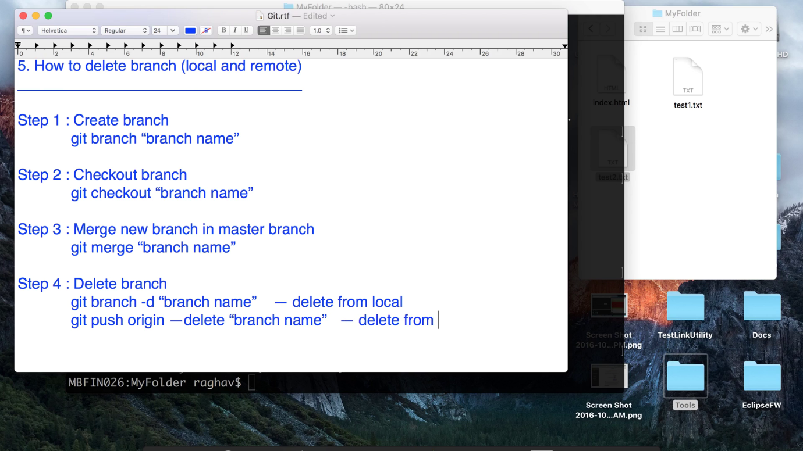

**Create branch practice :**

lpeddint@N-20HEPF0ZN03B MINGW64 /c/Content/web_project (master)

$ git status

On branch master

nothing to commit, working tree clean

lpeddint@N-20HEPF0ZN03B MINGW64 /c/Content/web_project (master)

$ clear

lpeddint@N-20HEPF0ZN03B MINGW64 /c/Content/web_project (master)

$ git pull origin master

From https://github.com/lpeddinti/web-project

* branch master -> FETCH_HEAD

Already up to date.

lpeddint@N-20HEPF0ZN03B MINGW64 /c/Content/web_project (master)

$ git branch Tourist-Proj

lpeddint@N-20HEPF0ZN03B MINGW64 /c/Content/web_project (master)

$ git checkout Tourist-Proj

Switched to branch 'Tourist-Proj'

lpeddint@N-20HEPF0ZN03B MINGW64 /c/Content/web_project (Tourist-Proj)

$ git status

On branch Tourist-Proj

nothing to commit, working tree clean

lpeddint@N-20HEPF0ZN03B MINGW64 /c/Content/web_project (Tourist-Proj)

$ pwd

/c/Content/web_project

lpeddint@N-20HEPF0ZN03B MINGW64 /c/Content/web_project (Tourist-Proj)

$ cd Tourist-Proj/

lpeddint@N-20HEPF0ZN03B MINGW64 /c/Content/web_project/Tourist-Proj (Tourist-Proj)

$ touch index.html

lpeddint@N-20HEPF0ZN03B MINGW64 /c/Content/web_project/Tourist-Proj (Tourist-Proj)

$ mv index.html Tourist.html

lpeddint@N-20HEPF0ZN03B MINGW64 /c/Content/web_project/Tourist-Proj (Tourist-Proj)

$ ls

Tourist.html

lpeddint@N-20HEPF0ZN03B MINGW64 /c/Content/web_project/Tourist-Proj (Tourist-Proj)

$ git status

On branch Tourist-Proj

Untracked files:

(use "git add <file>..." to include in what will be committed)

./

nothing added to commit but untracked files present (use "git add" to track)

lpeddint@N-20HEPF0ZN03B MINGW64 /c/Content/web_project/Tourist-Proj (Tourist-Proj)

$ cd ..

lpeddint@N-20HEPF0ZN03B MINGW64 /c/Content/web_project (Tourist-Proj)

$ pwd

/c/Content/web_project

lpeddint@N-20HEPF0ZN03B MINGW64 /c/Content/web_project (Tourist-Proj)

$ git status

On branch Tourist-Proj

Untracked files:

(use "git add <file>..." to include in what will be committed)

Tourist-Proj/

nothing added to commit but untracked files present (use "git add" to track)

lpeddint@N-20HEPF0ZN03B MINGW64 /c/Content/web_project (Tourist-Proj)

$ git add Tourist-Proj/

lpeddint@N-20HEPF0ZN03B MINGW64 /c/Content/web_project (Tourist-Proj)

$ git commit -a -m "create new branch called Tourist"

[Tourist-Proj 7ec1775] create new branch called Tourist

1 file changed, 0 insertions(+), 0 deletions(-)

create mode 100644 Tourist-Proj/Tourist.html

lpeddint@N-20HEPF0ZN03B MINGW64 /c/Content/web_project (Tourist-Proj)

$ git push origin Tourist-Proj

Counting objects: 4, done.

Delta compression using up to 4 threads.

Compressing objects: 100% (2/2), done.

Writing objects: 100% (4/4), 351 bytes | 117.00 KiB/s, done.

Total 4 (delta 0), reused 0 (delta 0)

remote:

remote: Create a pull request for 'Tourist-Proj' on GitHub by visiting:

remote: https://github.com/lpeddinti/web-project/pull/new/Tourist-Proj

remote:

To https://github.com/lpeddinti/web-project.git

* [new branch] Tourist-Proj -> Tourist-Proj

lpeddint@N-20HEPF0ZN03B MINGW64 /c/Content/web_project (Tourist-Proj)

**Merge branch to master practice:**

lpeddint@N-20HEPF0ZN03B MINGW64 /c/Content/web-project (master)

$ git push origin master

Everything up-to-date

lpeddint@N-20HEPF0ZN03B MINGW64 /c/Content/web-project (master)

$ git checkout Tourist-Proj

Switched to a new branch 'Tourist-Proj'

Branch 'Tourist-Proj' set up to track remote branch 'Tourist-Proj' from 'origin'.

lpeddint@N-20HEPF0ZN03B MINGW64 /c/Content/web-project (Tourist-Proj)

$ ls

test.txt Tourist-Proj/

lpeddint@N-20HEPF0ZN03B MINGW64 /c/Content/web-project (Tourist-Proj)

$ git checkout master

Switched to branch 'master'

Your branch is up to date with 'origin/master'.

lpeddint@N-20HEPF0ZN03B MINGW64 /c/Content/web-project (master)

$ ls

test.txt

lpeddint@N-20HEPF0ZN03B MINGW64 /c/Content/web-project (master)

$ git merge Tourist-Proj

Updating 75e6934..7ec1775

Fast-forward

Tourist-Proj/Tourist.html | 0

1 file changed, 0 insertions(+), 0 deletions(-)

create mode 100644 Tourist-Proj/Tourist.html

lpeddint@N-20HEPF0ZN03B MINGW64 /c/Content/web-project (master)

$ git push origin master

Total 0 (delta 0), reused 0 (delta 0)

To https://github.com/lpeddinti/web-project.git

75e6934..7ec1775 master -> master

lpeddint@N-20HEPF0ZN03B MINGW64 /c/Content/web-project (master)

$

**How to create tag and restore from tag:**

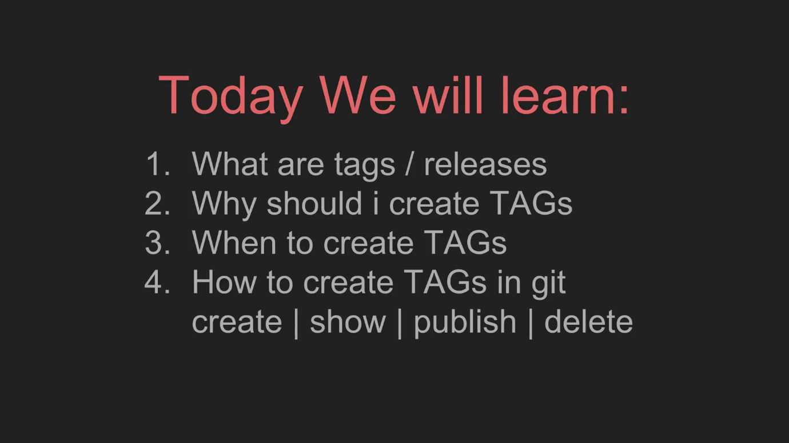



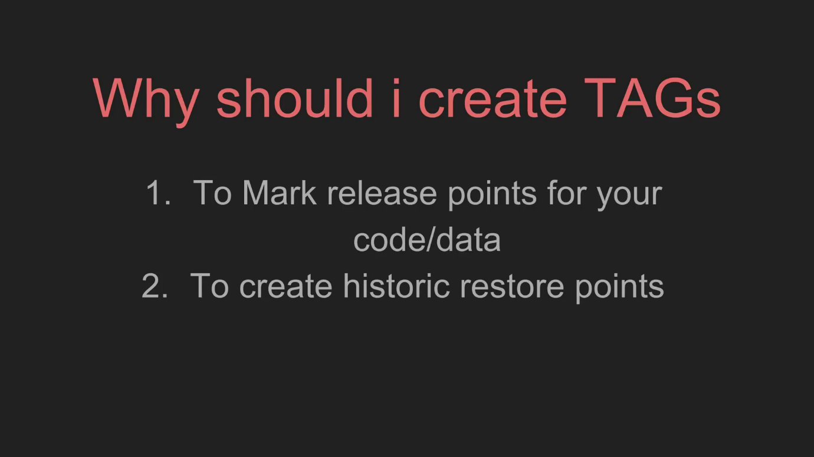

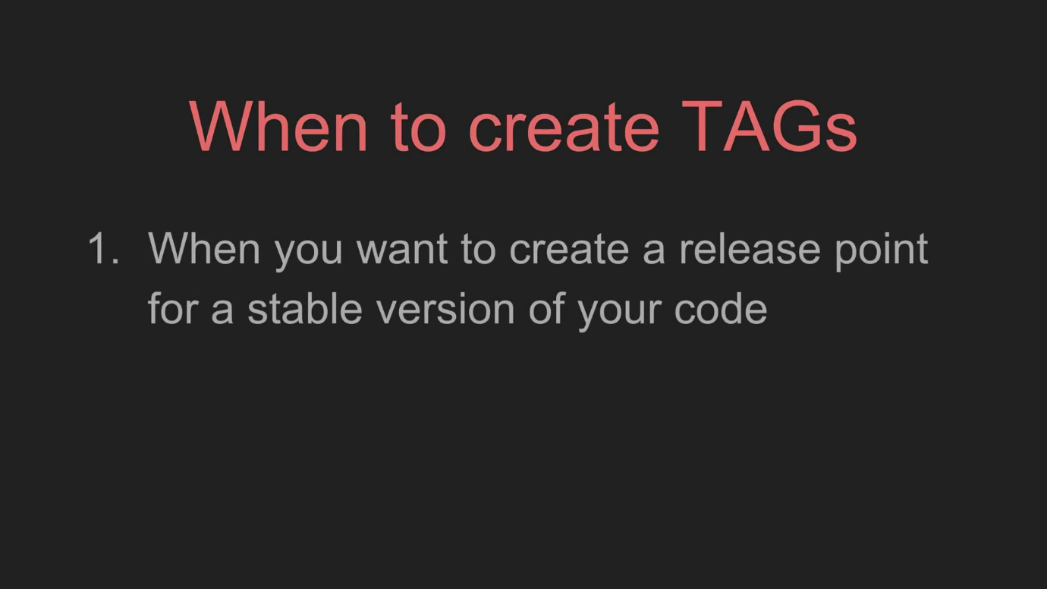

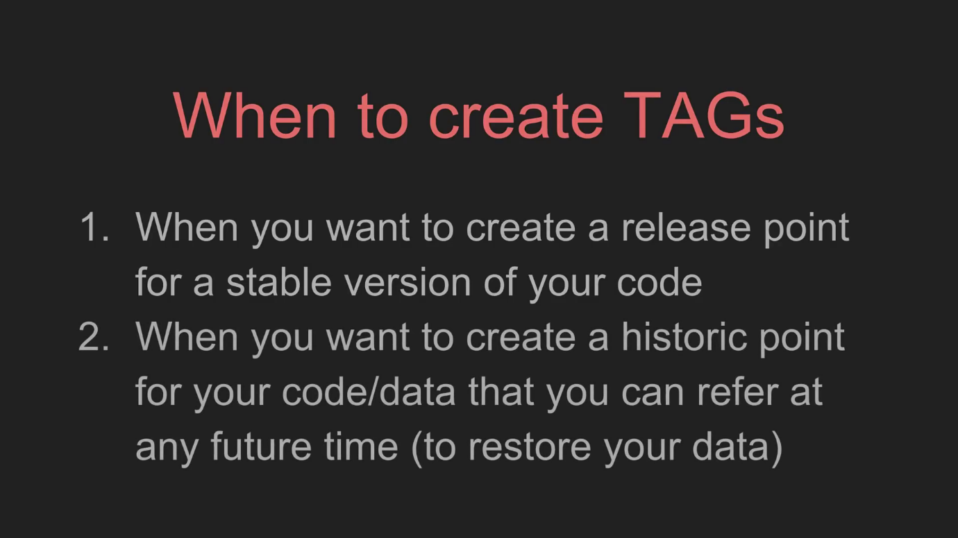

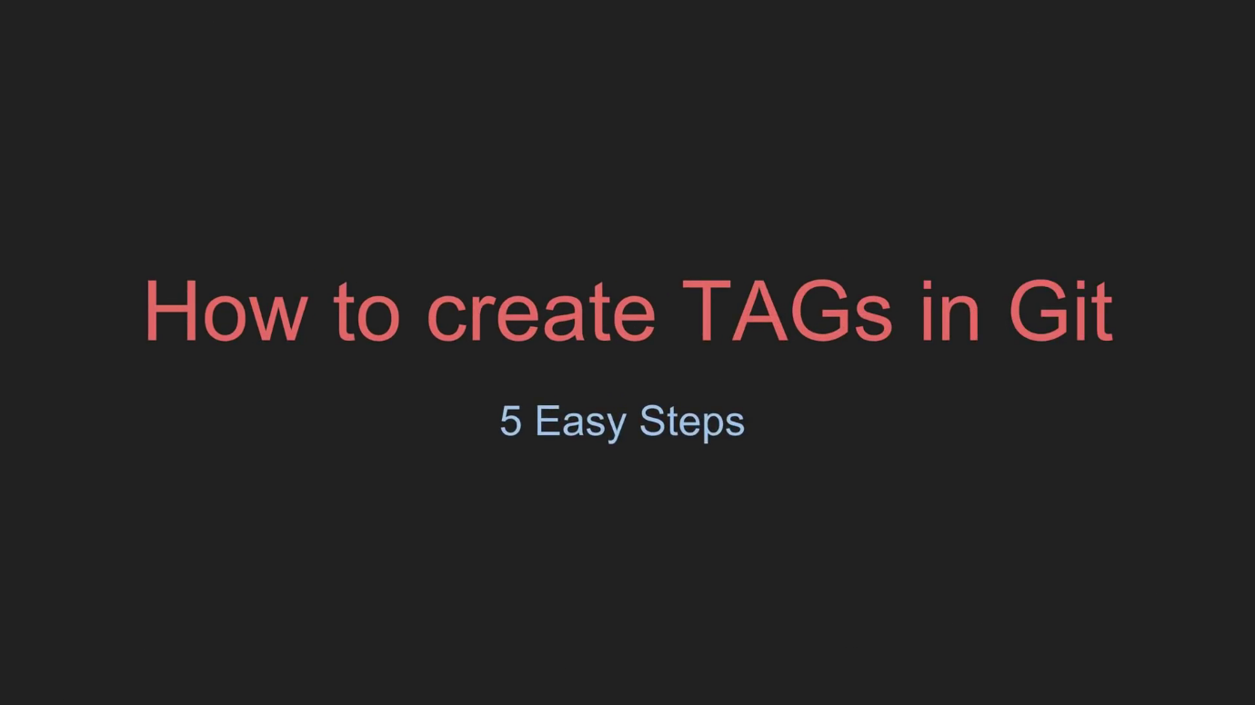

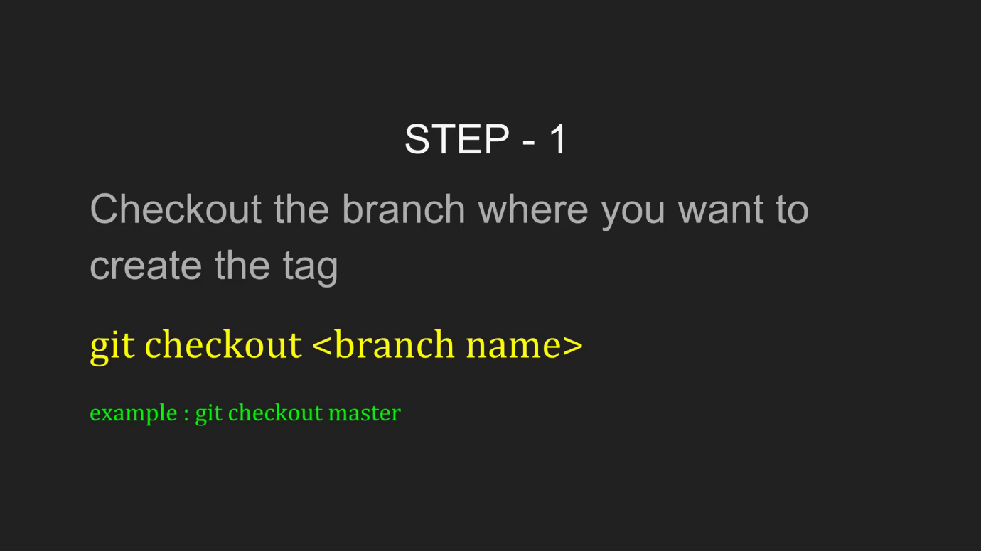

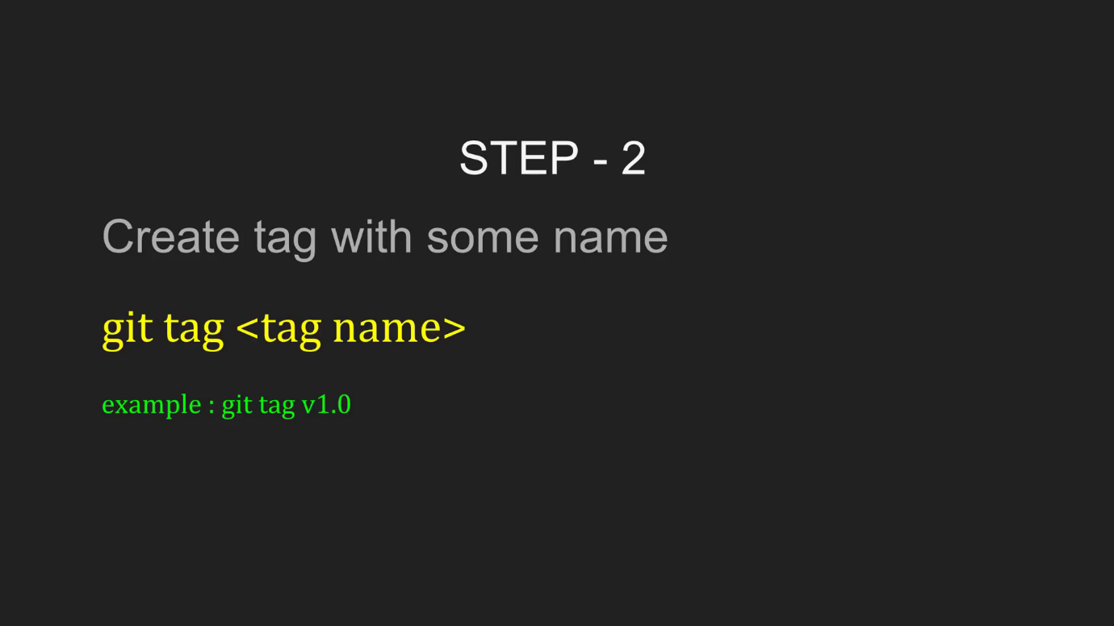

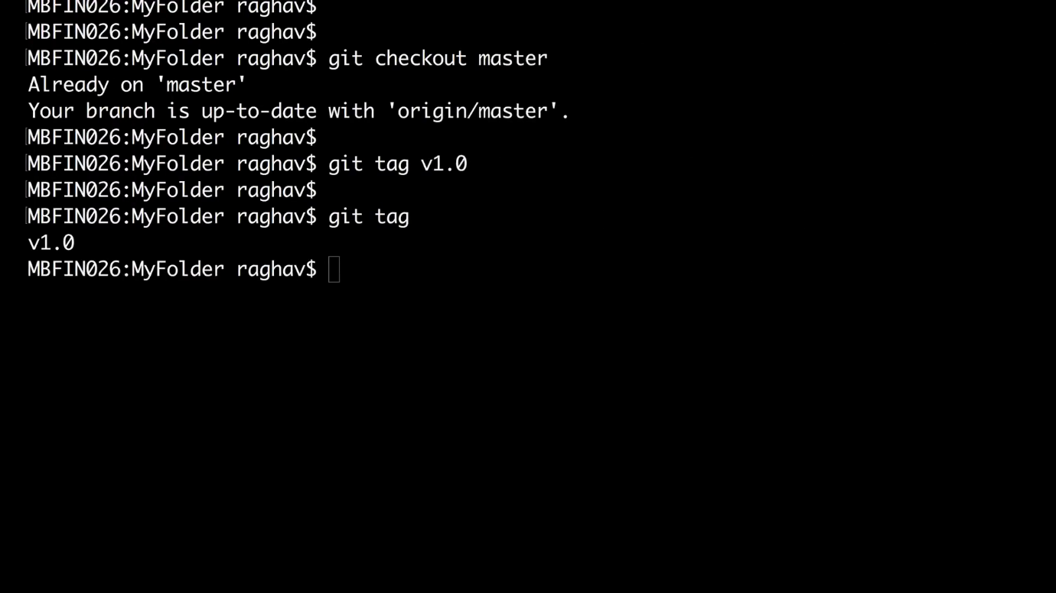

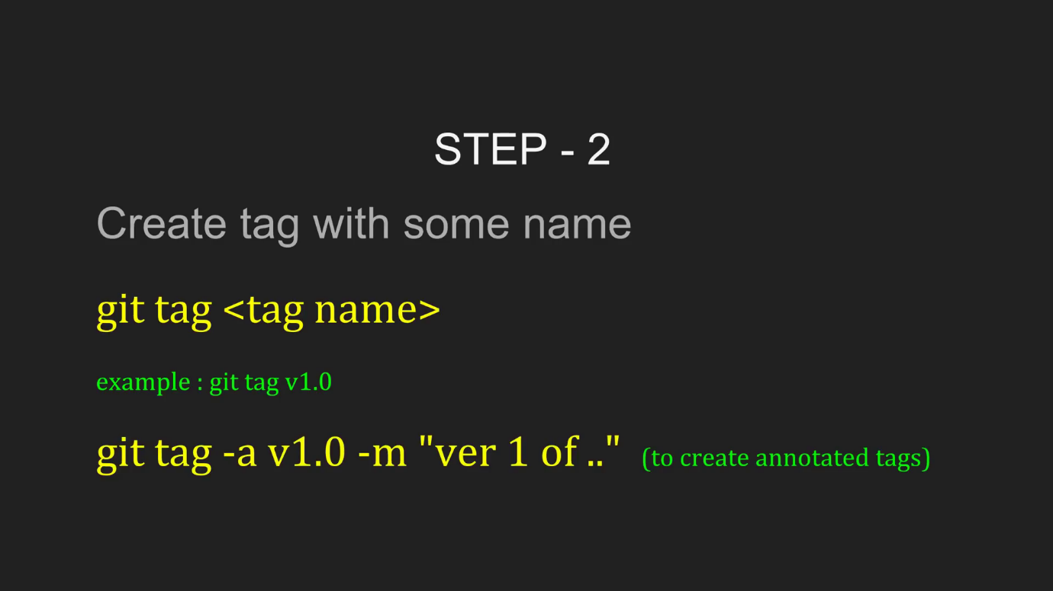

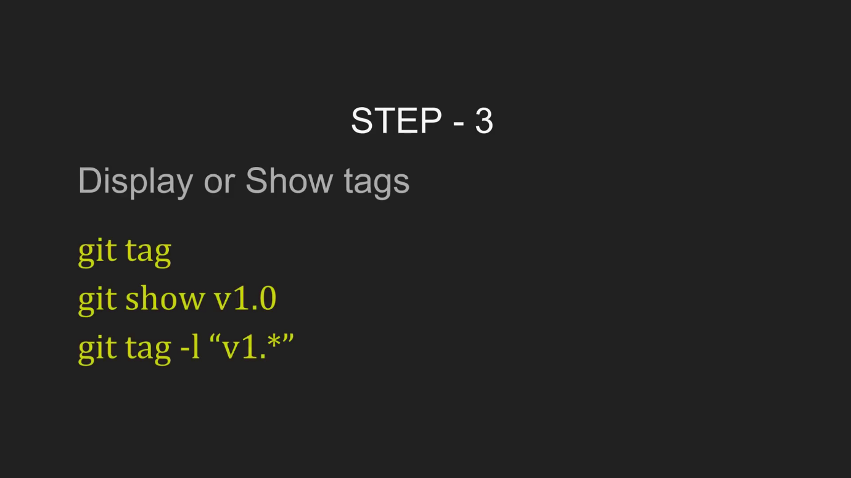

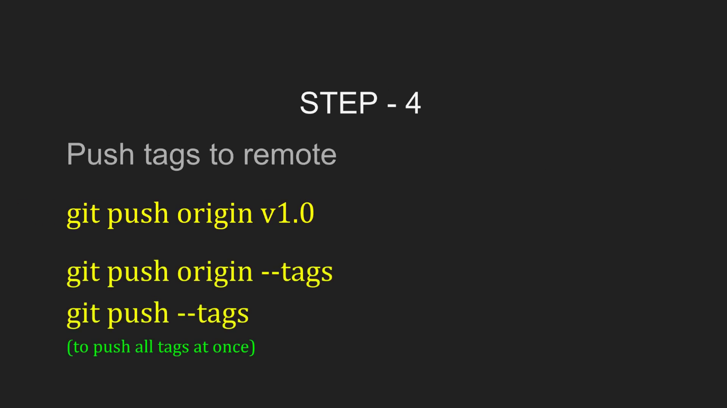

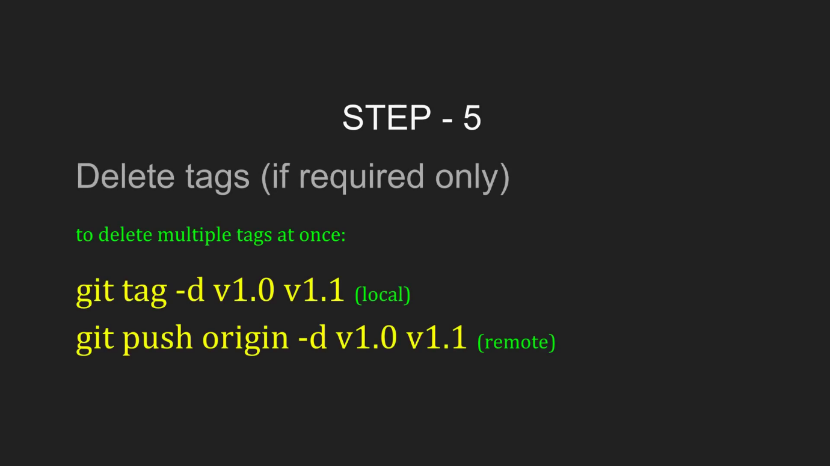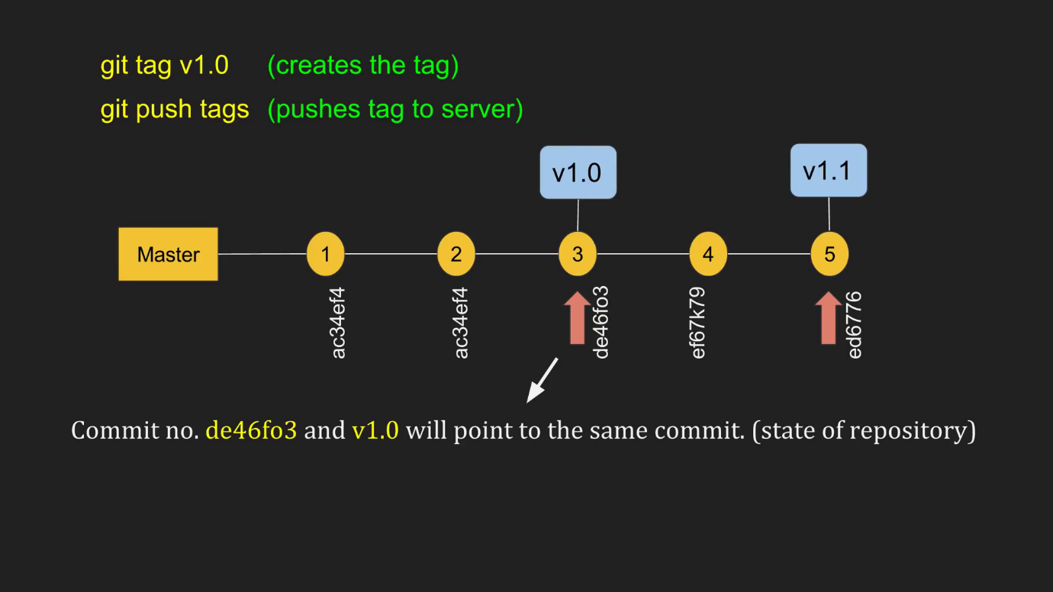

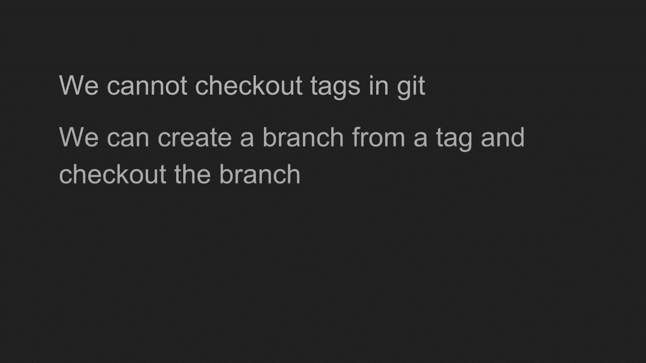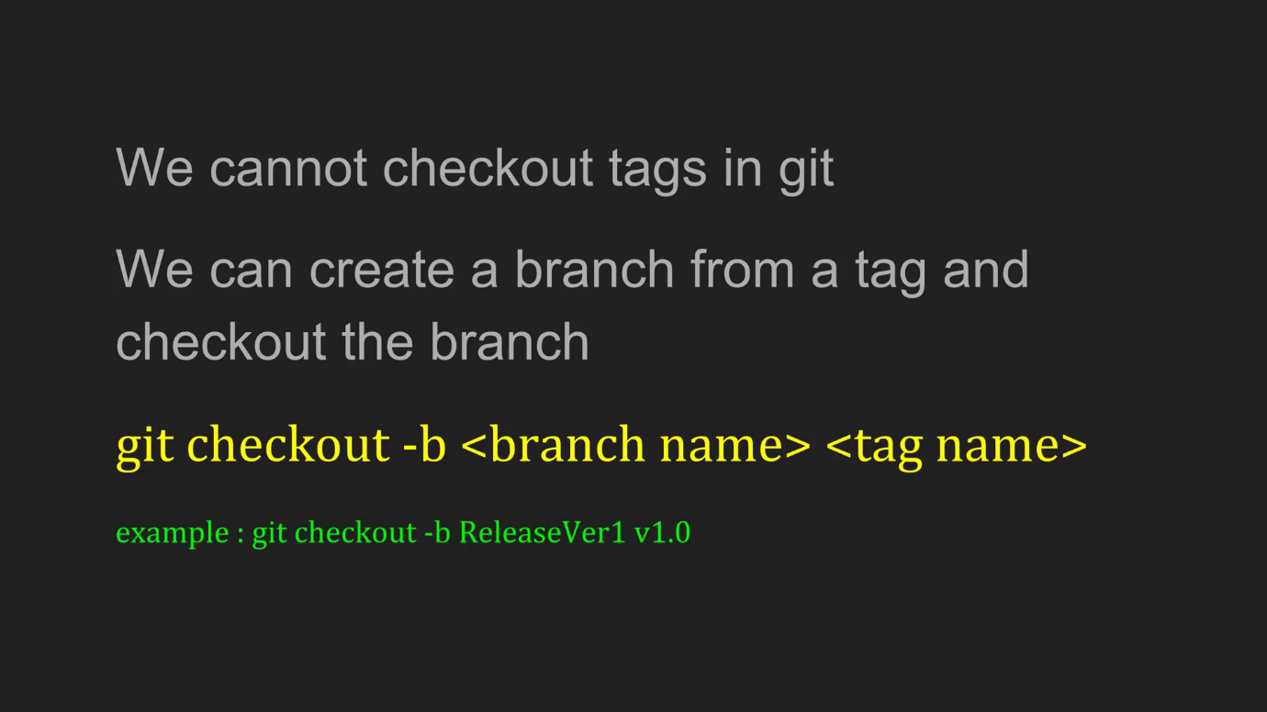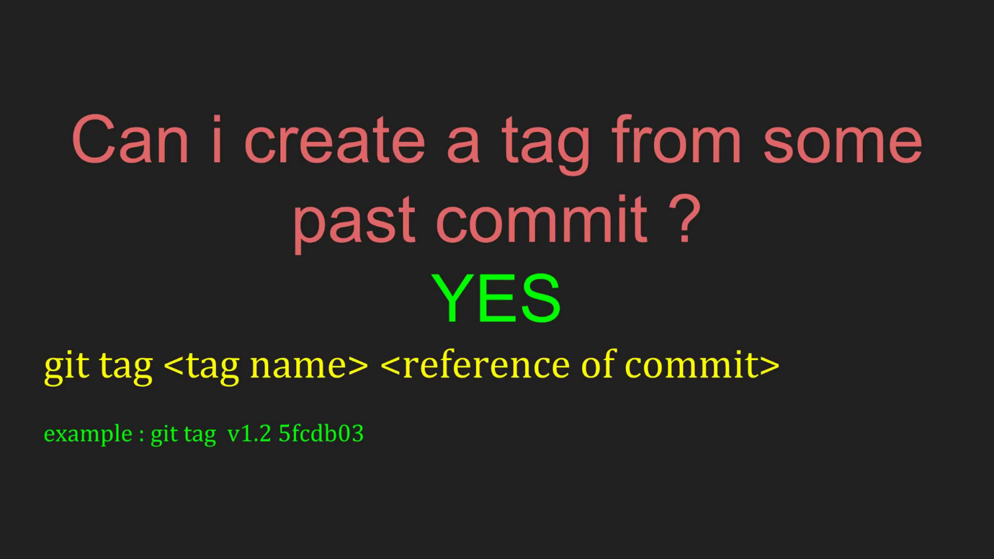

lpeddint@N-20HEPF0ZN03B MINGW64 /c/Content/web-project/Tourist-Proj (Tourist-Proj)

$ git push origin Tourist-Proj

Counting objects: 3, done.

Delta compression using up to 4 threads.

Compressing objects: 100% (3/3), done.

Writing objects: 100% (3/3), 354 bytes | 118.00 KiB/s, done.

Total 3 (delta 0), reused 0 (delta 0)

To https://github.com/lpeddinti/web-project.git

7ec1775..5c84174 Tourist-Proj -> Tourist-Proj

lpeddint@N-20HEPF0ZN03B MINGW64 /c/Content/web-project/Tourist-Proj (Tourist-Proj)

$ pwd

/c/Content/web-project/Tourist-Proj

lpeddint@N-20HEPF0ZN03B MINGW64 /c/Content/web-project/Tourist-Proj (Tourist-Proj)

$ git checkout -b newbranch v1.0

Switched to a new branch 'newbranch'

lpeddint@N-20HEPF0ZN03B MINGW64 /c/Content/web-project/Tourist-Proj (newbranch)

$ pwd

/c/Content/web-project/Tourist-Proj

lpeddint@N-20HEPF0ZN03B MINGW64 /c/Content/web-project/Tourist-Proj (newbranch)

$ touch restorev1.txt

lpeddint@N-20HEPF0ZN03B MINGW64 /c/Content/web-project/Tourist-Proj (newbranch)

$ git status

On branch newbranch

Untracked files:

(use "git add <file>..." to include in what will be committed)

restorev1.txt

nothing added to commit but untracked files present (use "git add" to track)

lpeddint@N-20HEPF0ZN03B MINGW64 /c/Content/web-project/Tourist-Proj (newbranch)

$ git add restorev1.txt

lpeddint@N-20HEPF0ZN03B MINGW64 /c/Content/web-project/Tourist-Proj (newbranch)

$ git commit -a -m "restored v1.0 to newbranch"

[newbranch 0ed5425] restored v1.0 to newbranch

1 file changed, 0 insertions(+), 0 deletions(-)

create mode 100644 Tourist-Proj/restorev1.txt

lpeddint@N-20HEPF0ZN03B MINGW64 /c/Content/web-project/Tourist-Proj (newbranch)

$ git push origin newbranch

Counting objects: 3, done.

Delta compression using up to 4 threads.

Compressing objects: 100% (3/3), done.

Writing objects: 100% (3/3), 352 bytes | 117.00 KiB/s, done.

Total 3 (delta 0), reused 0 (delta 0)

remote:

remote: Create a pull request for 'newbranch' on GitHub by visiting:

remote: https://github.com/lpeddinti/web-project/pull/new/newbranch

remote:

To https://github.com/lpeddinti/web-project.git

* [new branch] newbranch -> newbranch

lpeddint@N-20HEPF0ZN03B MINGW64 /c/Content/web-project/Tourist-Proj (newbranch)

$ git checkout master

Switched to branch 'master'

Your branch is up to date with 'origin/master'.

lpeddint@N-20HEPF0ZN03B MINGW64 /c/Content/web-project/Tourist-Proj (master)

$ git merge newbranch

Updating 7ec1775..0ed5425

Fast-forward

Tourist-Proj/restorev1.txt | 0

1 file changed, 0 insertions(+), 0 deletions(-)

create mode 100644 Tourist-Proj/restorev1.txt

lpeddint@N-20HEPF0ZN03B MINGW64 /c/Content/web-project/Tourist-Proj (master)

$ git push origin master

Total 0 (delta 0), reused 0 (delta 0)

To https://github.com/lpeddinti/web-project.git

7ec1775..0ed5425 master -> master

lpeddint@N-20HEPF0ZN03B MINGW64 /c/Content/web-project/Tourist-Proj (master)

$ git merge Tourist-Proj

Merge made by the 'recursive' strategy.

Tourist-Proj/afterrel.txt | 0

1 file changed, 0 insertions(+), 0 deletions(-)

create mode 100644 Tourist-Proj/afterrel.txt

lpeddint@N-20HEPF0ZN03B MINGW64 /c/Content/web-project/Tourist-Proj (master)

$ git push origin master

Counting objects: 3, done.

Delta compression using up to 4 threads.

Compressing objects: 100% (3/3), done.

Writing objects: 100% (3/3), 399 bytes | 133.00 KiB/s, done.

Total 3 (delta 0), reused 0 (delta 0)

To https://github.com/lpeddinti/web-project.git

0ed5425..023deba master -> master

lpeddint@N-20HEPF0ZN03B MINGW64 /c/Content/web-project/Tourist-Proj (master)

$

These are common Git commands used in various situations:

start a working area (see also: git help tutorial)

clone Clone a repository into a new directory

init Create an empty Git repository or reinitialize an existing one

work on the current change (see also: git help everyday)

add Add file contents to the index

mv Move or rename a file, a directory, or a symlink

reset Reset current HEAD to the specified state

rm Remove files from the working tree and from the index

examine the history and state (see also: git help revisions)

bisect Use binary search to find the commit that introduced a bug

grep Print lines matching a pattern

log Show commit logs

show Show various types of objects

status Show the working tree status

grow, mark and tweak your common history

branch List, create, or delete branches

checkout Switch branches or restore working tree files

commit Record changes to the repository

diff Show changes between commits, commit and working tree, etc

merge Join two or more development histories together

rebase Reapply commits on top of another base tip

tag Create, list, delete or verify a tag object signed with GPG

collaborate (see also: git help workflows)

fetch Download objects and refs from another repository

pull Fetch from and integrate with another repository or a local branch

push Update remote refs along with associated objects

**Git creation of repo:**

**git init**

**git add untracked files**

**git commit -m “message ”**

**git remote add origin <url>**

**git push origin master**

**git clone url**

**cd to directory**

**git add <new files created locally>**

**git commit -m <>**

**git push origin master**

**git branch creation:**

**git clone master**

**git branch <branch-name>**

**git checkout <branch-name>**

**git add <files>**

**git commit -m <message>**

**git push origin <branch-name>**

**git branch merge:**

**git merge <branch-name>**

**git push origin master**

**git branch deletion:**

**git branch -d/--delete <branch-name> - local repo deletion**

**git push origin -d/--delete <branch-name> - to delete at remote repo**

**git tag creation:**

**git checkout <branch-name>**

**git tag <tag-name>**

**git push origin <tag-name>**

**git checkout <tag-name> or git checkout -b <new-branch> <tag-name> - to create branch from tag**

**git tag deletion:**

**git tag -d <tag-name>**

**git push origin -d <tag-name>**